Interfacing the BacT/VIEW® Computer
With BacT/LINK® or MicroNET™ Software

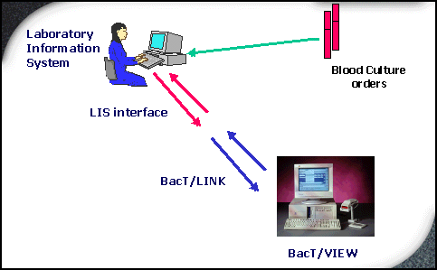
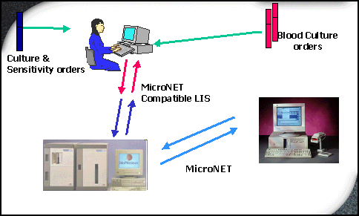

Interfacing The BacT/VIEW® computer with BacT/LINK® or MicroNETTM Software

• CAPABILITY:

BacT/LINK is an Interface package that allows the existing BacT/VIEW software to provide a seamless bi-directional exchange of data between the BacT/VIEW and the Laboratory’s Information System (LIS).

MicroNET is a bi-directional interface that allows the VITEK and BacT/ VIEW to exchange patient information, exam data, organism identifications, and smear results. It can be used in laboratories with or without a Laboratory Information System (LIS). If used in a lab where the VITEK interfaces with an LIS, then downloaded patient demographics transfer over to the BacT/VIEW via MicroNET.

• COMPATIBILITY:

BacT/LINK and MicroNET Interface software conform to industry-approved standards developed by the American Society for Testing and Materials (ASTM). A copy of these standards may be obtained from: 100 Barr Harbor Drive, West Conshohocken, PA 19428.

• FUNCTIONALITY:

The downloading of demographic data to the BacT/VIEW computer by interfacing with the LIS allows the technologist to omit various manual data entry steps. One may simply enter the accession number on the Quick Data Entry screen and associate it with the appropriate bottle(s). Bi-directional interfacing allows the BacT/VIEW to send final results for accessions back to the LIS.

BacT/LINK® Features

• Automatically accepts patient and specimen data from the LIS.
• Automatically transmits new test results to the LIS, if desired.
• Eliminates redundant entry of patient and specimen data into BacT/VIEW, saving technologist time and reducing chances of clerical errors.
• Eliminates the entry of test results into the LIS (bi-directional) again saving technologist time and speeding up the reporting of results to the physician.
• Centralizes all test data into one location.
• Conforms to industry-approved ASTM standards.
• Supports a wide variety of LIS data fields.

Data Supported by BacT/LINK Interface Software*

• Patient Information

Hospital ID Physician Discharge Date Hospital Service
Name Height Admission Status Hospital/Institution
Sex Weight Location Lab-Defined Fields
Birthdate Diagnosis Religion Comments
Race Medications Marital Status
Address Diet Isolation Status
Telephone Number Admission Date Language

• Accession Information

Accession Number Ordered Date/Time Priority Physician Telephone
Location Collection End Time Specimen Source Specimen Service
Collected Date/Time Collection Volume Clinical Information Lab-Defined Fields
Received Date/Time Danger Code Ordering Physician Comments
Collected By

• Bottle Information

Bottle ID Maximum Test Time Loaded Date/Time Lab-Defined Fields
Bottle Type Status Status Date/Time Comments

*Data supported are dependent on the LIS’ capability.

MicroNET™ Features

• Improves accuracy by minimizing transcription errors.
• Reduces cost with single point data entry.
• Reduces expenses by eliminating multiple LIS connections.
• Consolidates positive Blood Culture and organism ID information
into a single record.
• Provides improved data communications with Clinical Pharmacy.

Data supported by MicroNET Interface Software

Hospital ID Sex Date Collected Accessions Comment
Last Name Comment Time Collected Accession Number
First Name Source Date Received Organisms
Birthdate Location Time Received Collected By
Smears

BacT/LINK™ INTERFACE INSTALLATION ON A BacT/VIEW® COMPUTER

- Select the Configuration icon (1) on the lower right hand side of the Monitor Screen to open up the Configuration Screen. (You must have unrestricted access for this option to be active).

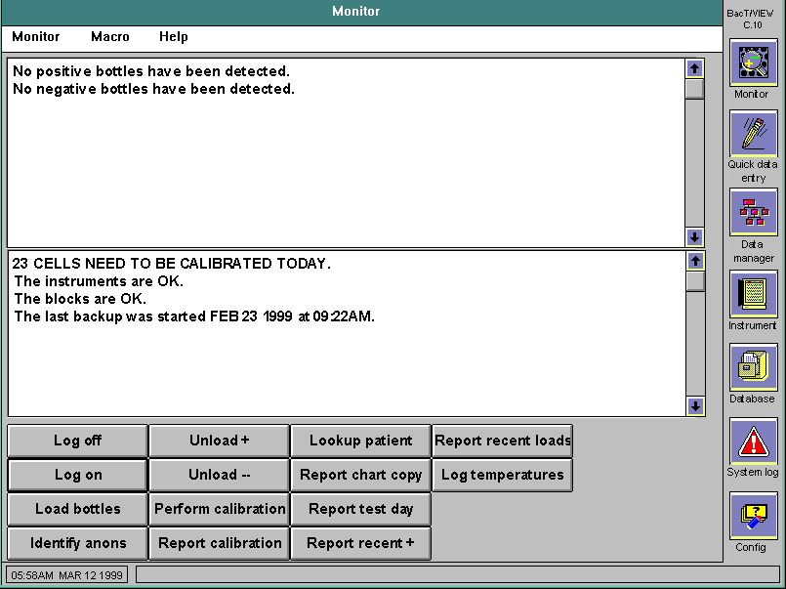
1

- There are no menus or fields on the Configuration screen, only navigational icons that link the user with specific configuration screens. Press the Interface Configuration icon (2).

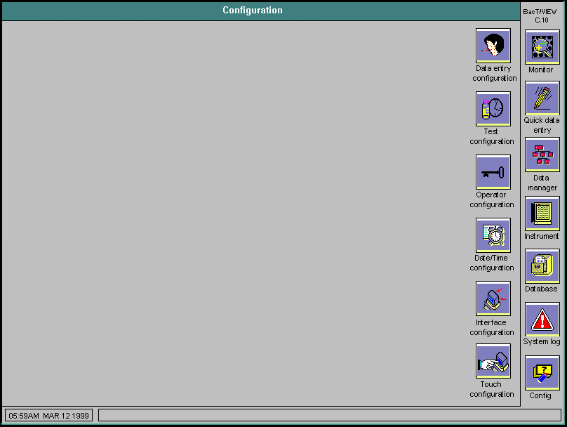
2

- A screen with a dialogue box will come to view saying: “The interface option has not been installed. Would you like to install it now?” Select the Yes button (3).

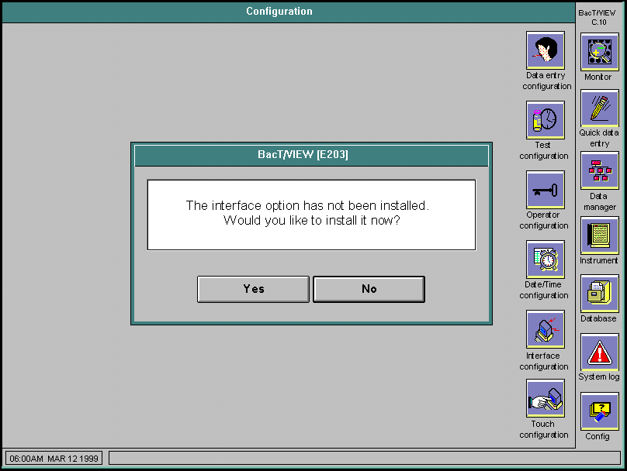
3

- You will be prompted to load the 3½ “BacT/LINK for BacT/VIEW” disk into Drive A. Load the disk into drive A and press Yes (4) to continue with the installation of the interface software. Press NO if you do not want to install the interface option at this time.

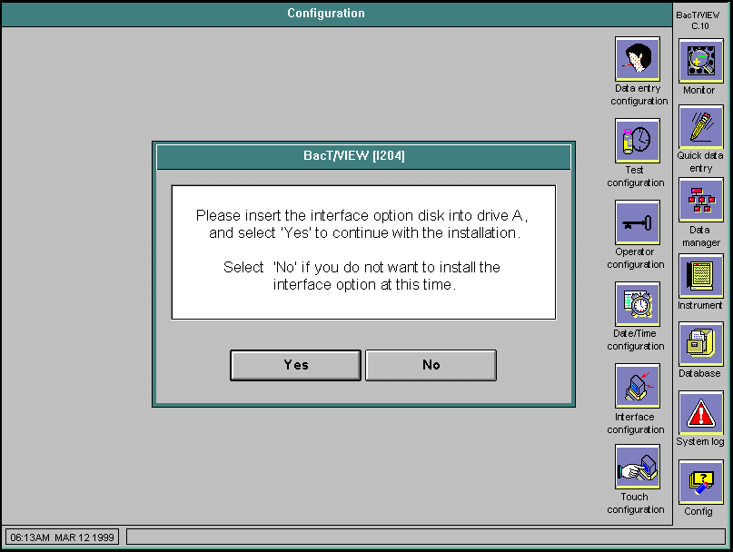
4

- A screen will appear that says “The BacT/LINK option is now installed. Remove the installation disk from the floppy drive now.” Press OK (5).

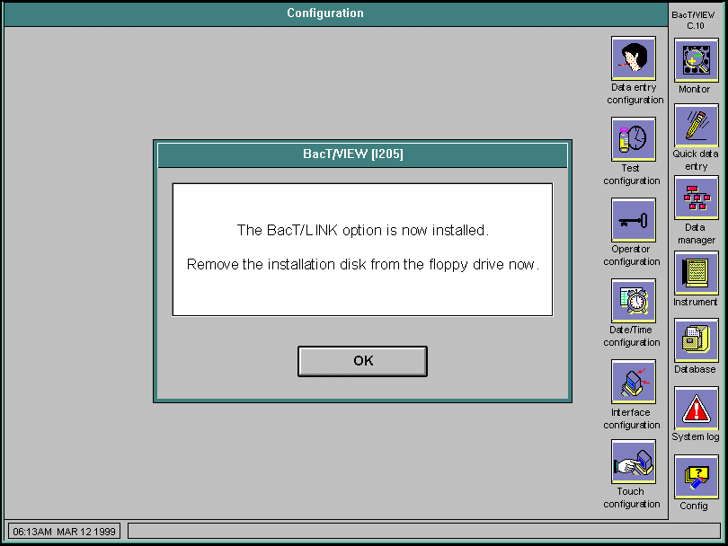
5

- The Enter Activation Code screen will appear telling you that “Your system’s interfacing functions will not be fully functional until you enter a valid interface Activation Code below. To obtain a valid Activation Code, reverse the 4-digit code reported (e.g., 4202 from the screen below), and divide by 9001. This number (4202/9001=4668 is your valid Activation Code. Enter the (e.g., 4668) Activation Code (6) and press OK (7) to continue or CANCEL to quit.
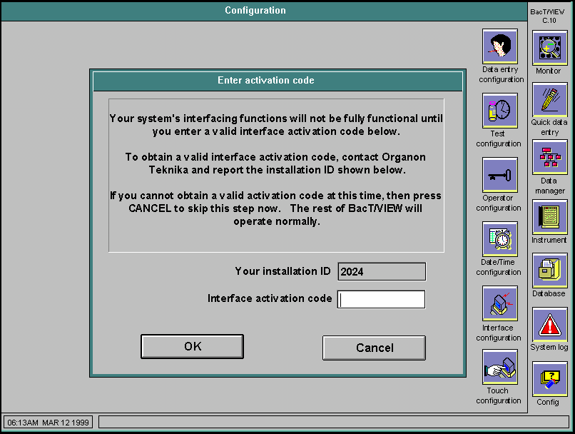

6
7

7. A screen will appear stating that the interface options are now operational. Press OK (8).

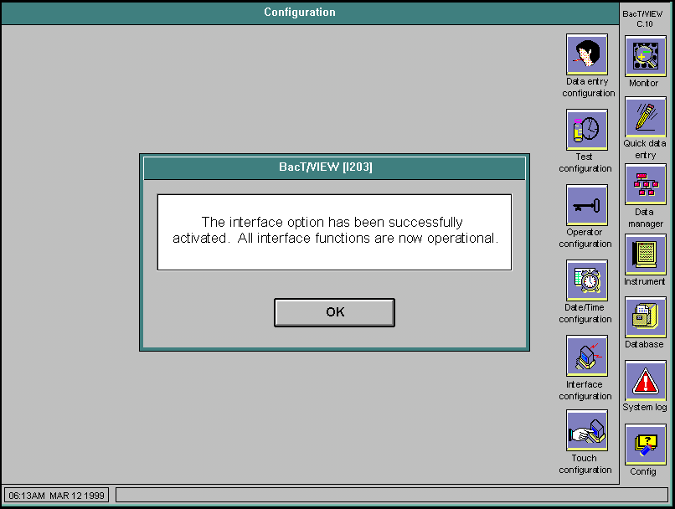
8

- The editable fields on the Interface Configuration Screen must be set according to the LIS parameter requirements. The BacT/LINK default settings appear in the screen below.
“Show Interface Status on the Monitor Screen” may be set to NO if the LIS system is not operational. This will avoid error messages appearing in the System Status Message Box on the Monitor Screen until the LIS is activated. If the LIS system is operational, this should be set to YES (9).

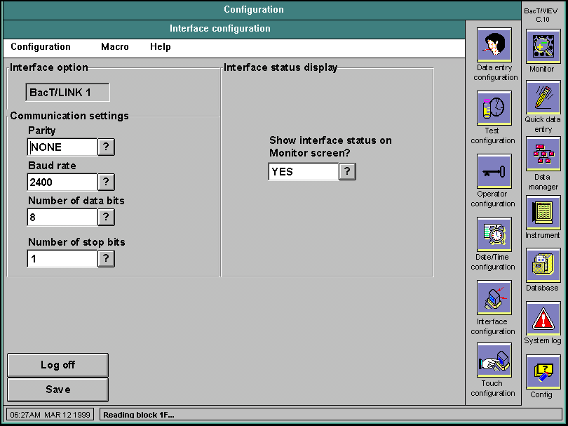
9

- Schedule Macros as required by your LIS to:

A. “Request new test orders” – automatically requests new orders if there is no dynamic/automatic download from the LIS to the BacT/VIEW computer (MicroNET does not require this macro).
- “Send new test results” - automatically sends the final negative and positive results from the BacT/VIEW computer to the LIS via a bi-directional interface.
C. “Delete accessions with no bottles” – automatically deletes accessions with no bottles attached to them. This is for MicroNET and other dynamic downloads to BacT/VIEW that send cultures (i.e., urines, wounds) that have no blood culture bottles attached after 48 hours.

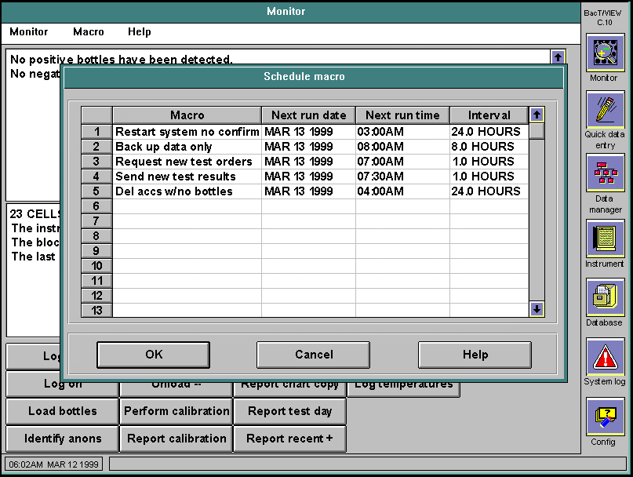

B

A
C

- The Interface Associated Macros can also be accessed and run manually from the Data Manager Screen. They are located on the Accession Data Window in the “Accession Drop Down” menu, and will perform the requested action on the Browse list selected. (View One (10) allows action on one record and Table View (11) allows action on all records in the Browse list.)

10
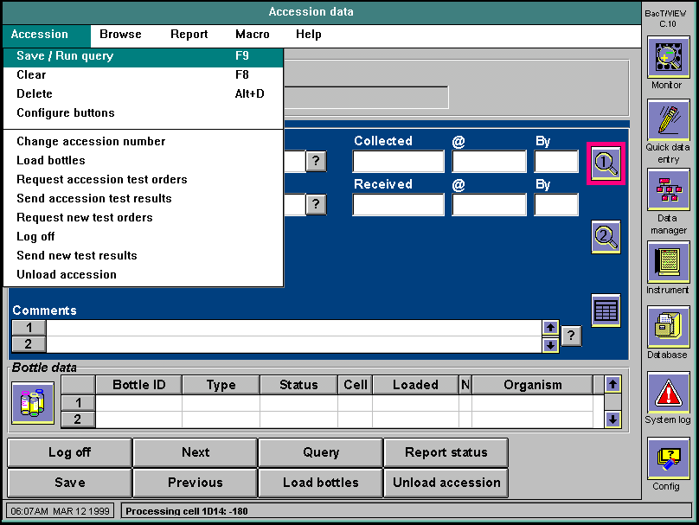
11

Sample Workflow Using Your Interface

LIS downloads of patient demographics and specimen information to BacT/Alert or BacT/VIEW eliminate the need for duplicate data entry. To use the interface:

• Go to the Quick Data Entry screen and wand or type in the accession number. The patient demographics will appear on the screen.

• Wand in the bottles associated with this accession in the bottle ID field and press Save.

• Load bottles by pressing the Load Bottles button in BacT/Alert and BacT/VIEW systems, or load bottles at the BacT/ALERT 3D™ Controller Module into available cells.

For Cerner™ LIS users:

• Using the Cerner Bottle ID Barcode, go to the Load Bottles button and wand in the bottle. The patient demographics will appear on the Load Bottles screen for the BacT/Alert and BacT/VIEW systems. Load the bottles as directed.

• For the BacT/ALERT 3D system, go to the Quick Data Entry Screen in BacT/ VIEW and wand in the accession number or Bottle ID Barcode. Verify that the patient information in BacT/VIEW is correct. Use the Load Bottles function on the BacT/ALERT 3D Controller Module to load the bottles into the system.

Troubleshooting Your Interface

 Do not press the “” in the instructions below - they indicate keystroke or touchscreen selections only:

When BacT/LINK or MicroNET cannot perform a function normally, they display the following message in the Instrument Status Message Box on the Monitor Screen of the BacT/VIEW computer:

The interface failed for the following reason.

This message will then be followed by a description of the error condition. The complete listing of these error conditions and how to address them can be found in either the “Troubleshooting” section of the BacT/LINK manual or in the “Troubleshooting the Interface” section of the MicroNET Manual. The following are preliminary actions that can be taken to investigate an interface failure:

- Check the physical connection of the interface cable on the back of the computer. The interface always uses Com Port 1 in the back of the computer and cannot be changed (see page 13 for BacT/Alert Data Management System Rear View).

- Check the Interface Configuration screen to be sure the parameters are set to the LIS requirements correctly.

- Log on with an Unrestricted Operations password and choose “Exit BacT/VIEW” from the Monitor Drop Down Menu on the Monitor Screen. Double click on the “—“ box in the upper left most area of the Program Manager Screen to close the screen and then “Exit Windows”. When a black screen appears saying it is OK to power down the system, turn the computer OFF. Thoroughly check cable connections again. After 20 seconds, turn the computer ON to cold boot the system and automatically reset the interface.

- If the error persists in a NEW interface installation, go to the Monitor Screen and press
“Ctrl+Shift+F5” on the keyboard to bring up a blue TCL line. Type:

“CLEAR_OUT_INTERFACE” and press “ENTER”

 This command clears any pending interface activity to be transmitted and should be used on NEW systems only. It should NOT be used on a system that has been sending data successfully.

- Reset the interface on the LIS side according to the directions for the LIS.

- If the interface error persists after these basic actions, call bioMérieux Technical Service for assistance.

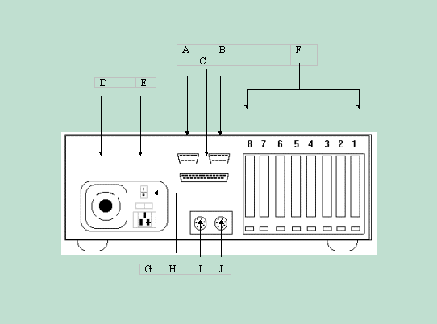
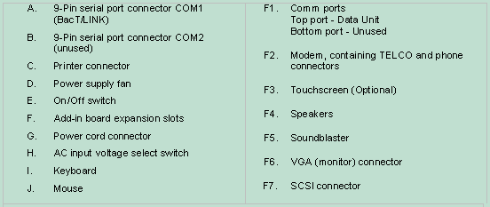

BacT/Alert Data Management System Rear View

Appendix A: Interface Case Studies

